**Lesson 9 Demo 2**

**Adding Hosts to the Nagios Monitoring Tool**



Steps to be followed:

1. Logging into the Nagios XI Dashboard
2. Adding a host using the core config manager

**Step 1: Logging into the Nagios Dashboard**

1. Login to the nagios dashboard using the url as mentioned in the previous demo.

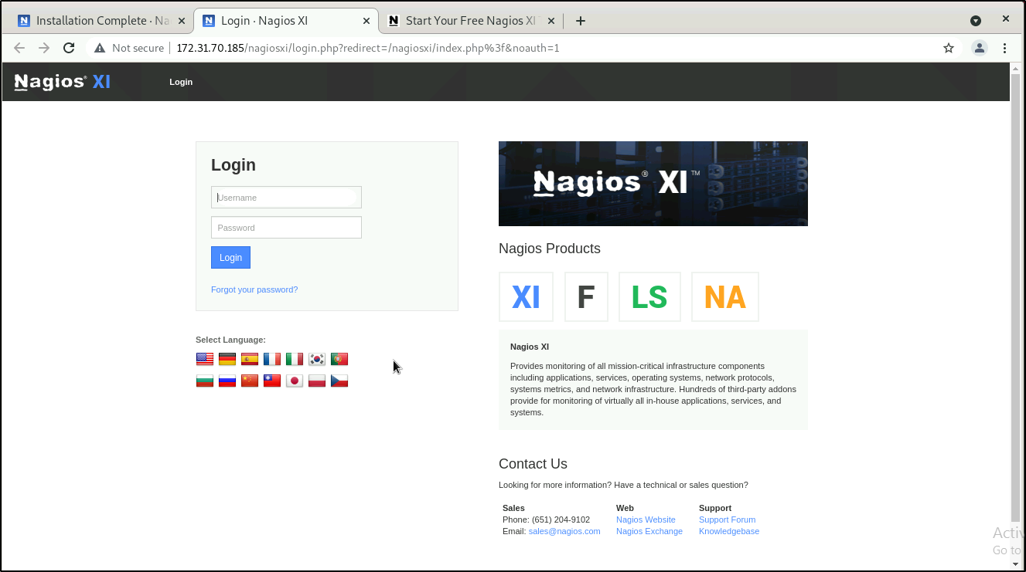

**Step 2: Adding a host using the core config manager**

1. Navigate to **Configure** > **Core config manager** from the nagios dashboard

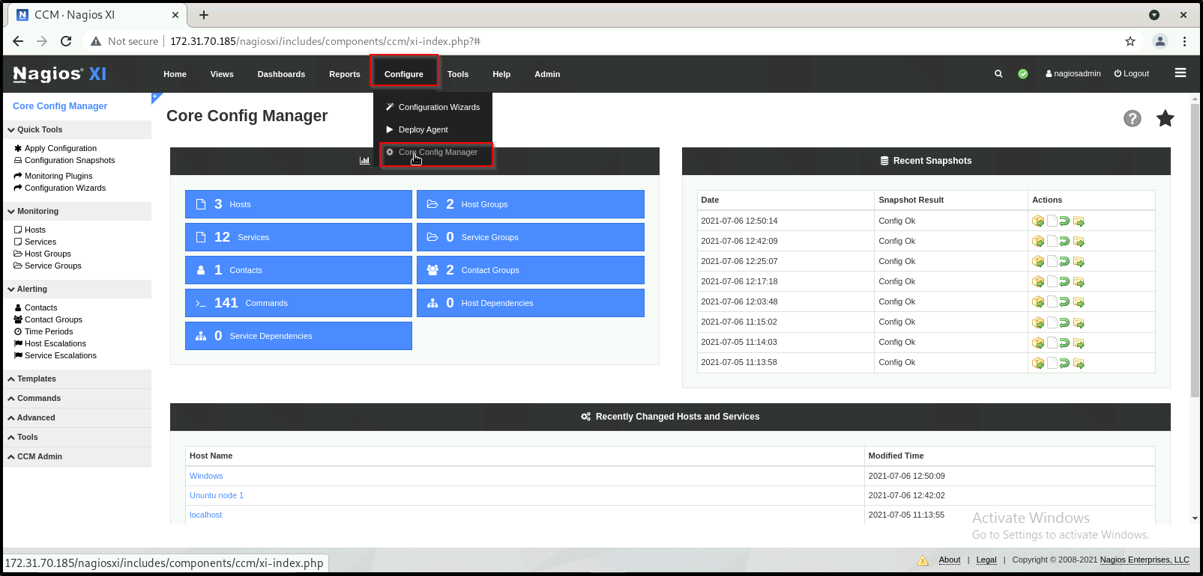

1. To manually add a new host, select the Hosts link located under Monitoring on the left menu of CCM

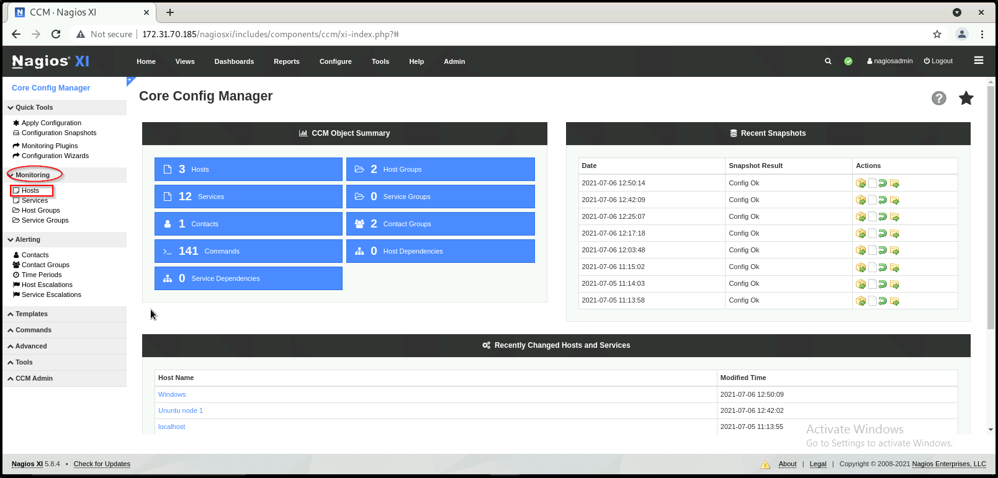

1. This will bring up the Host Management page, which displays a list of the current hosts being monitored by Nagios XI.

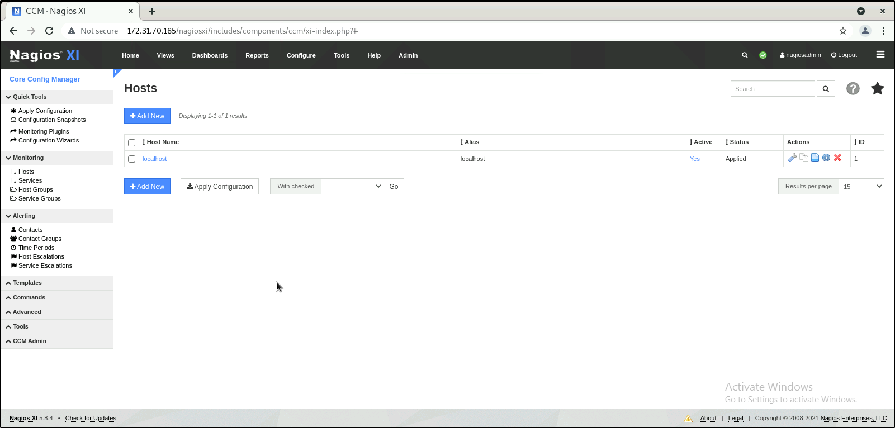

1. Click the Add New button to manually add a new host.

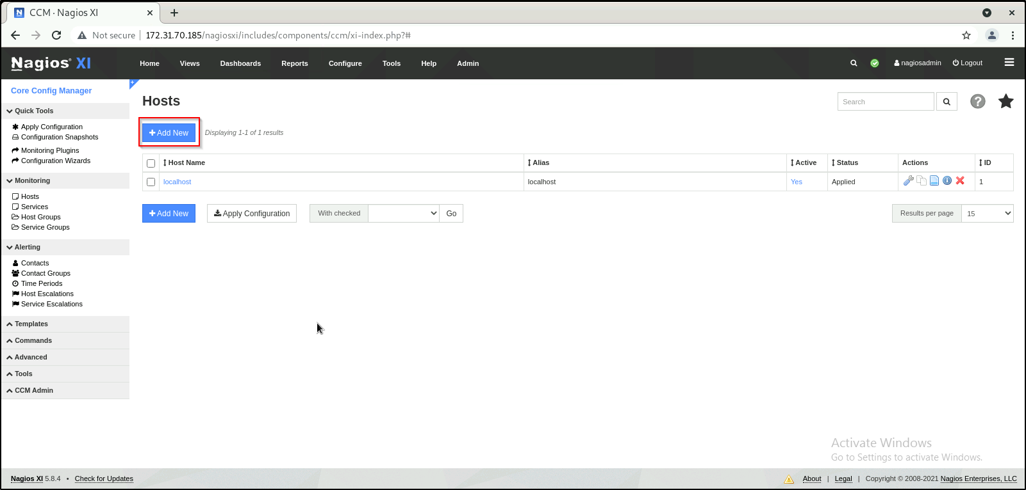

1. The Host Management page will open on the Common Settings tab.

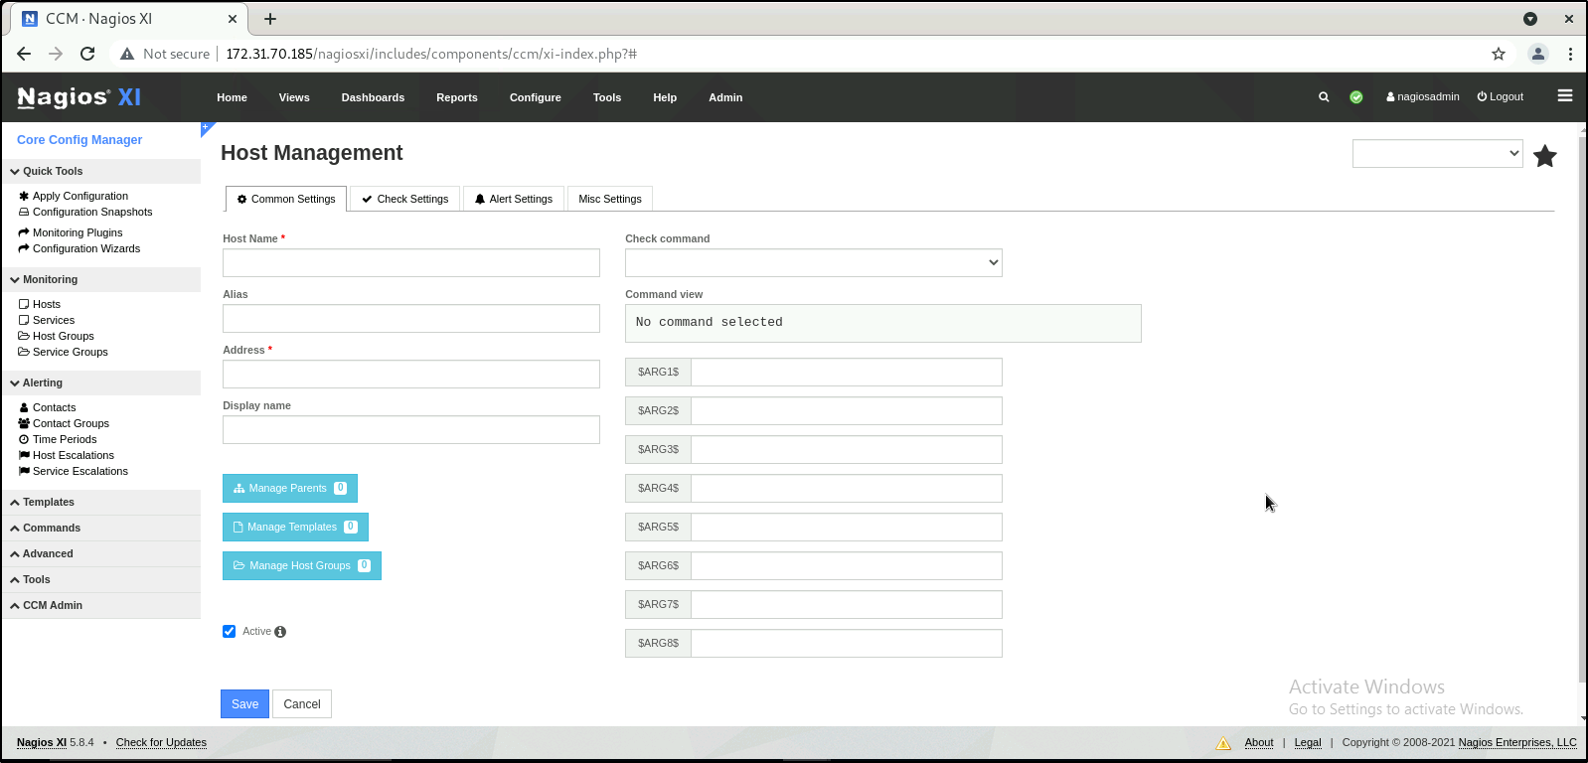

1. Define the primary host parameters such as Host Name, Description, Address, and Display name.

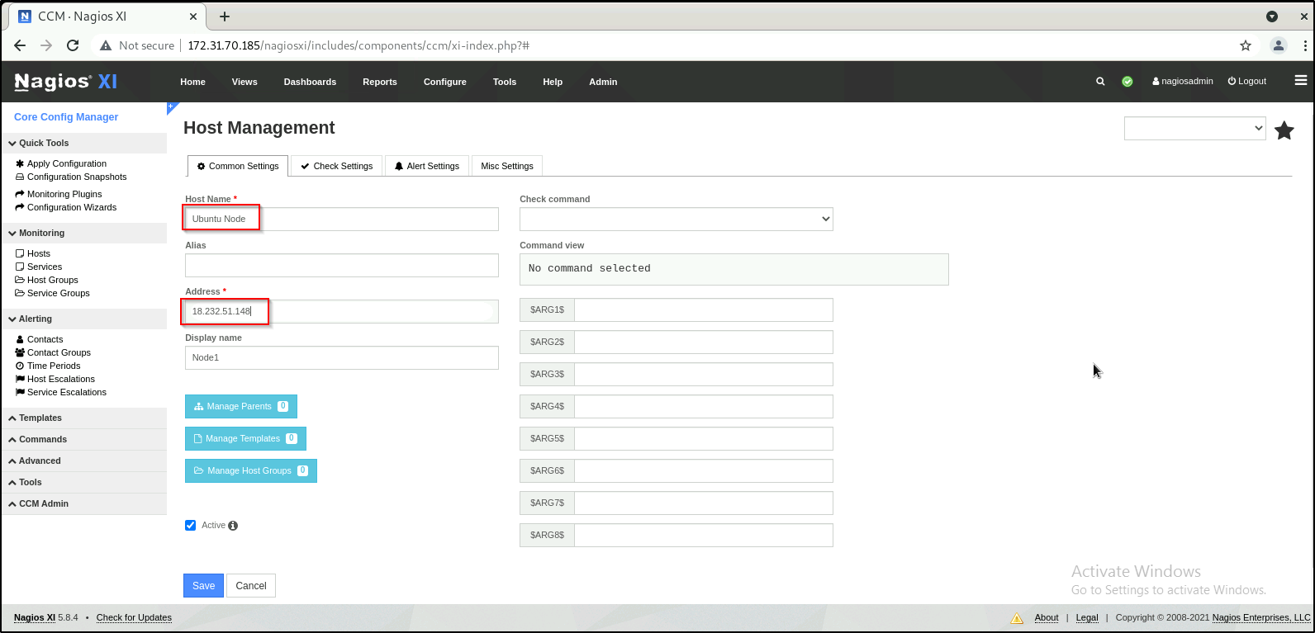

1. Use the Manage Parents button to associate parent host(s) for the host.
2. Use the Manage Templates button to associate template(s) to the host.

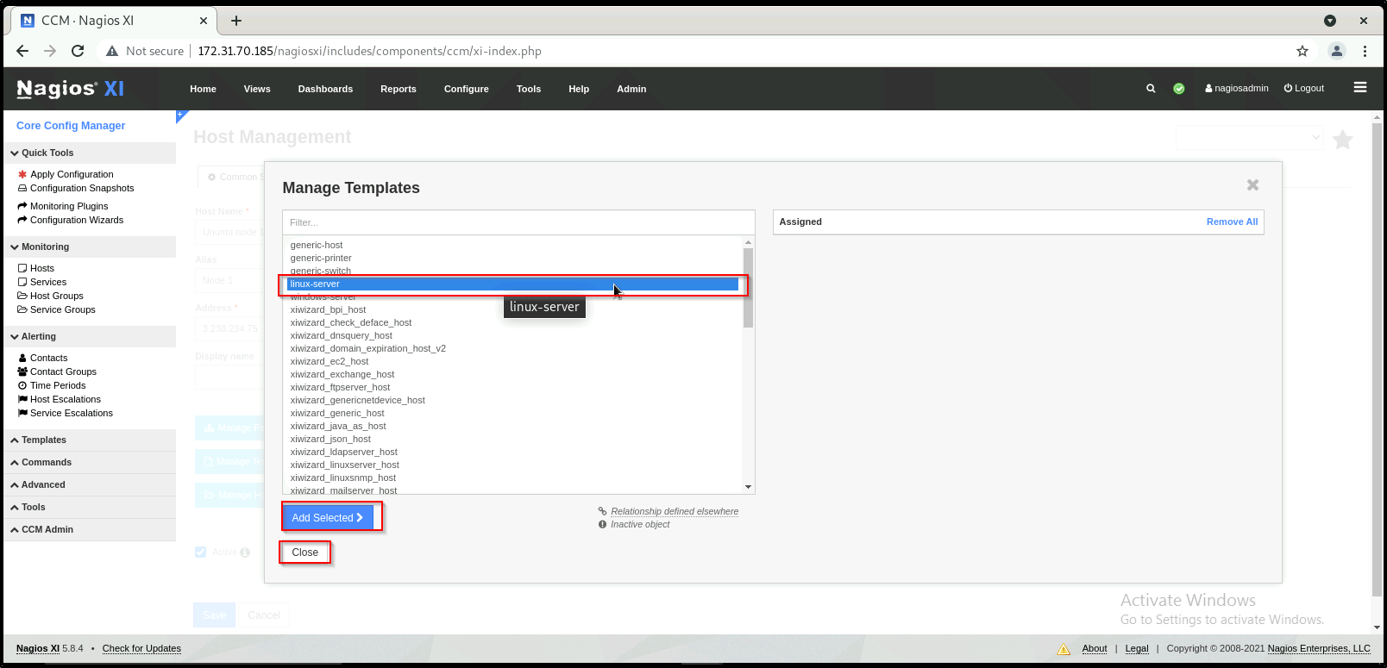

1. Use the Manage Host Groups button to associate existing host group(s) to the host

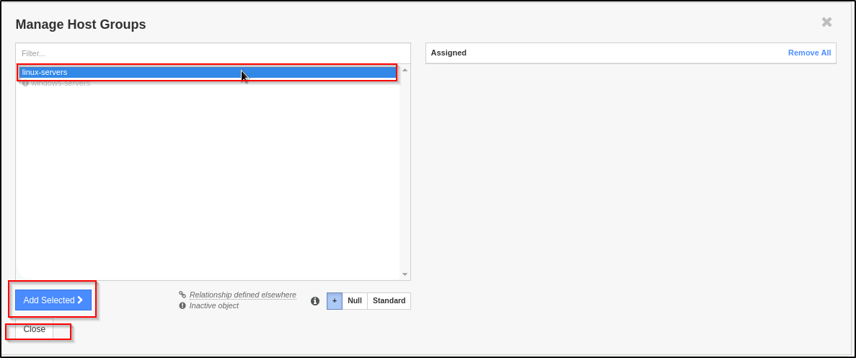

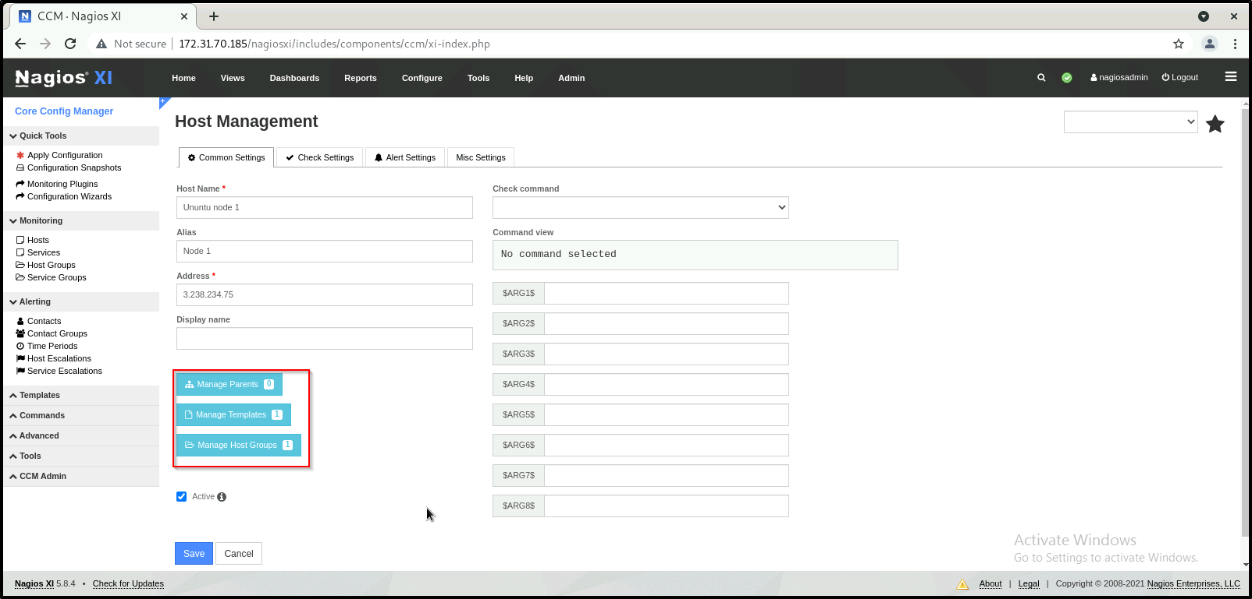

1. On the previous screenshot of the Common Settings tab you'll notice that the Active checkbox is checked. If this box is unchecked the host configuration won't be put into production when Apply Configuration is performed. However the settings will remain in CCM until you activate the host object.

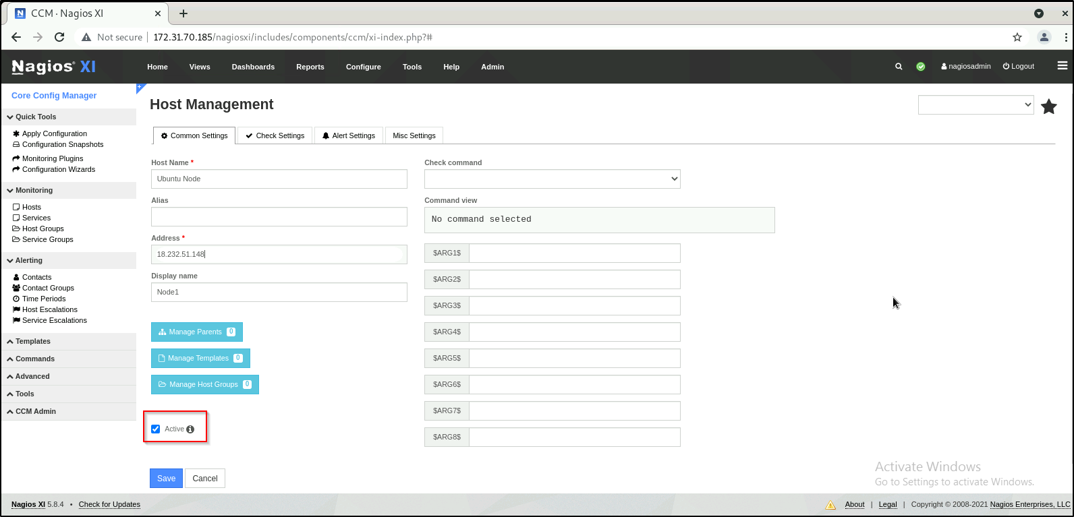

1. To define the check command for this host, you select the appropriate command from the Check command drop down list . Every command in the Check command drop down list is associated with a set of Nagios Core commands and arguments, which are shown in the Command view field.

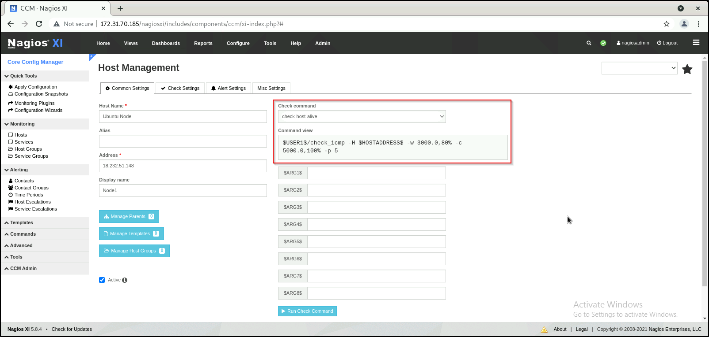

1. The Check Settings tab allows you to specify the settings for frequency of checks and also the host state

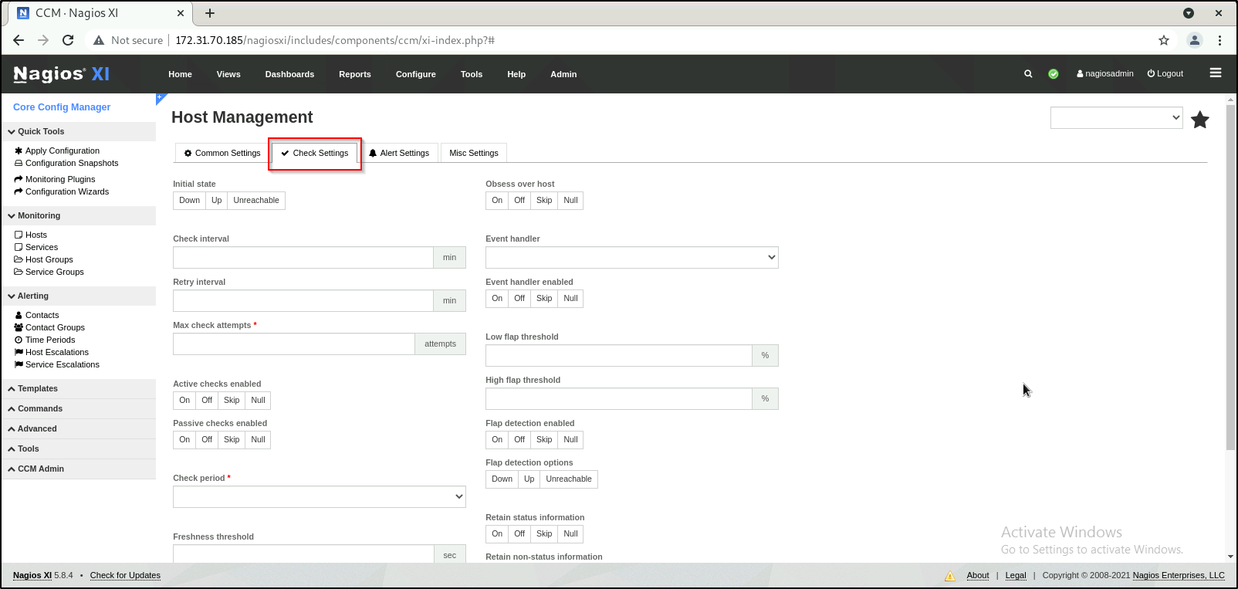

1. Configure settings as shown in the screenshot below

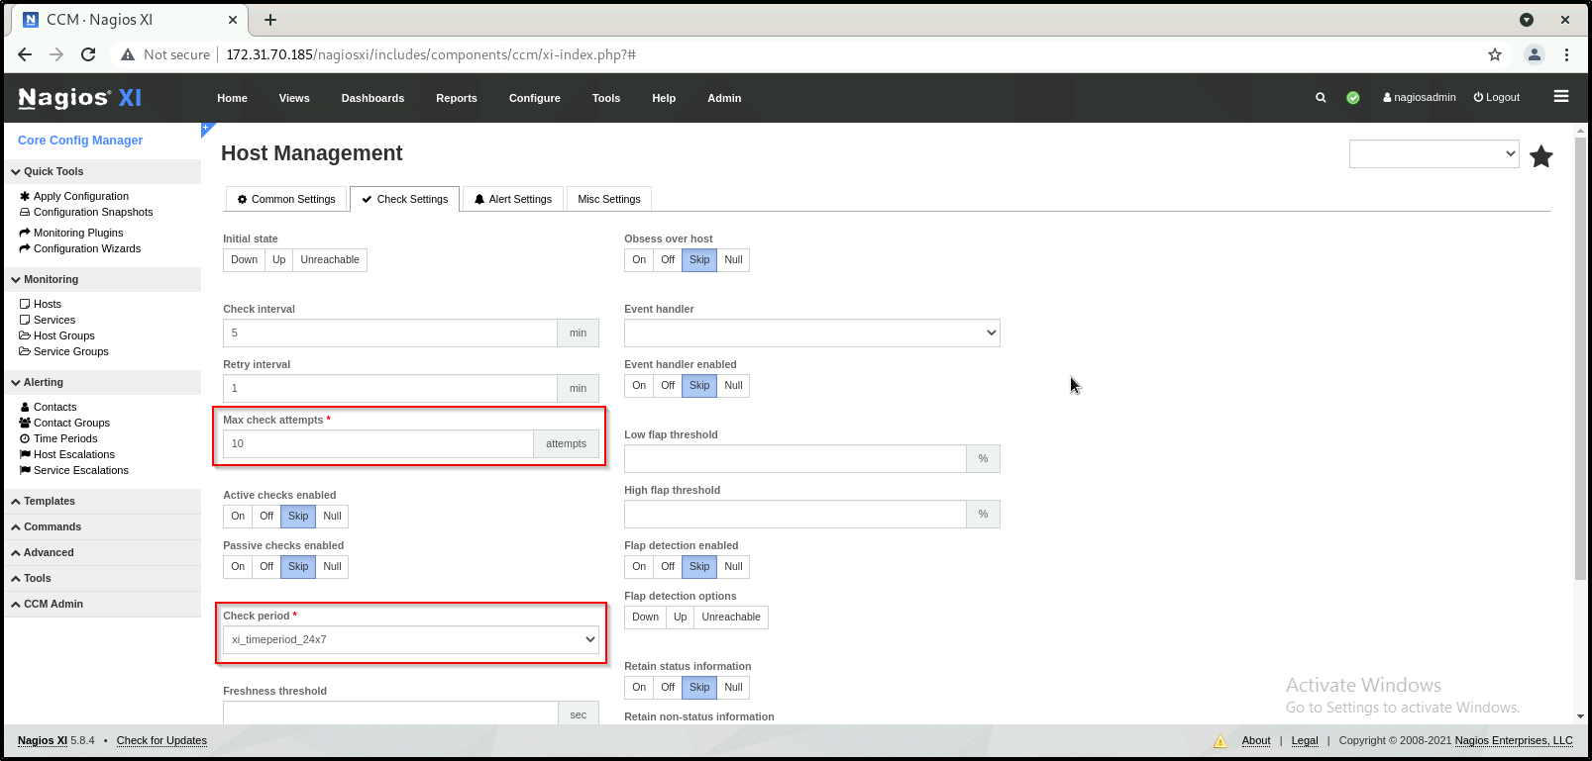

1. The Alert Settings tab allows you to specify your notification settings.

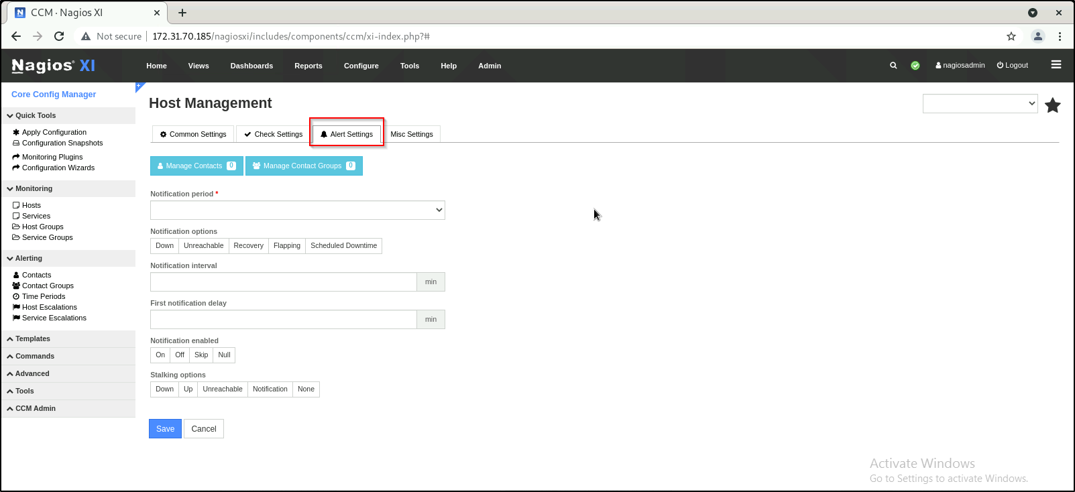

1. Enter the value as shown below:

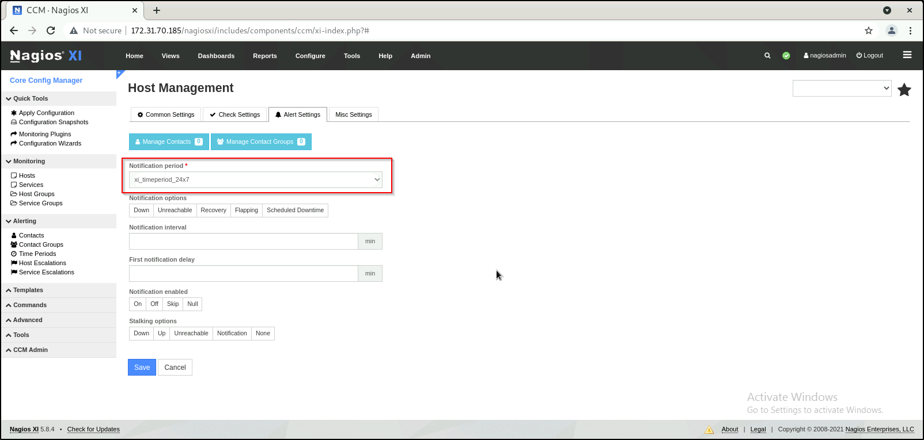

1. Click on manage contacts to add any contact that needs to be notified about the host status.

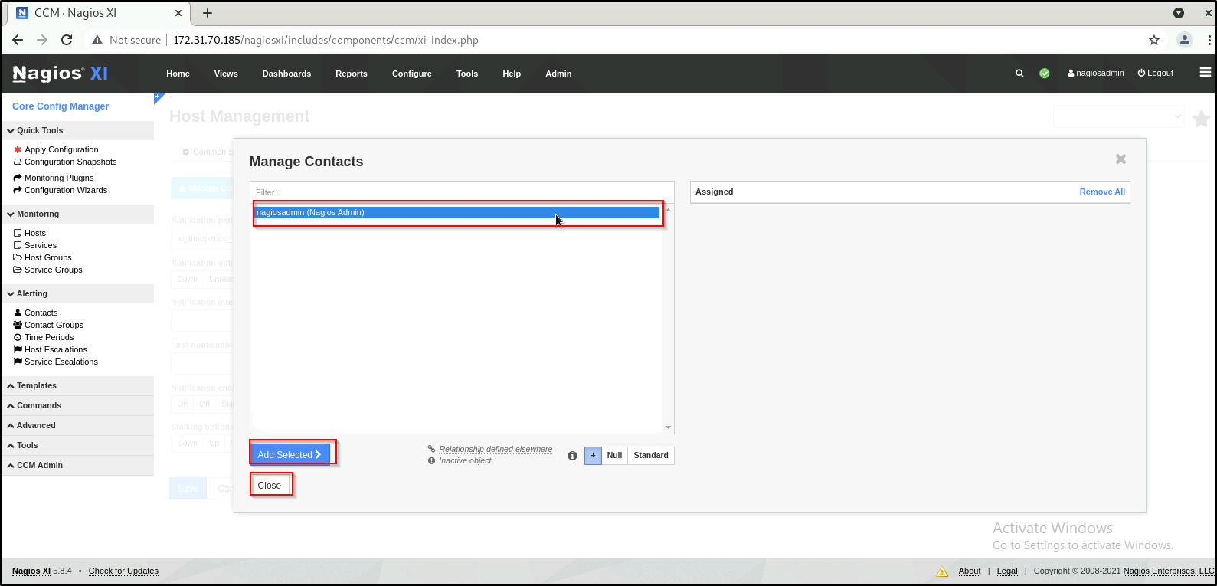

1. The Misc Settings tab is for defining additional host information

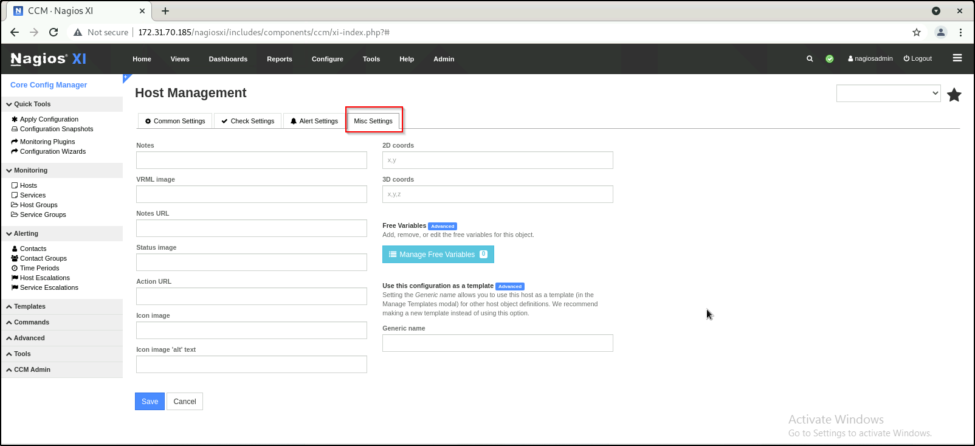

1. Once you've finished entering information for your new host, click the Save button to return to the Host Management page

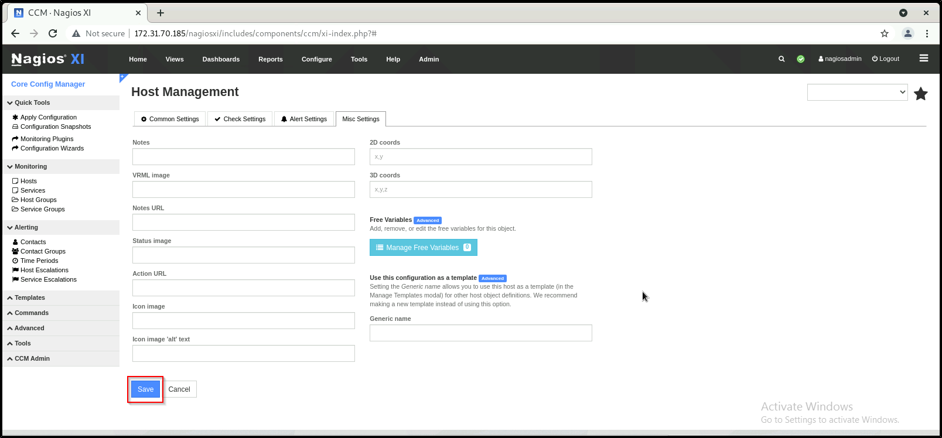

1. Click the Apply Configuration button to restart Nagios XI and put the new settings info effect. Nagios XI will verify the settings and display a success message that the host was set up correctly

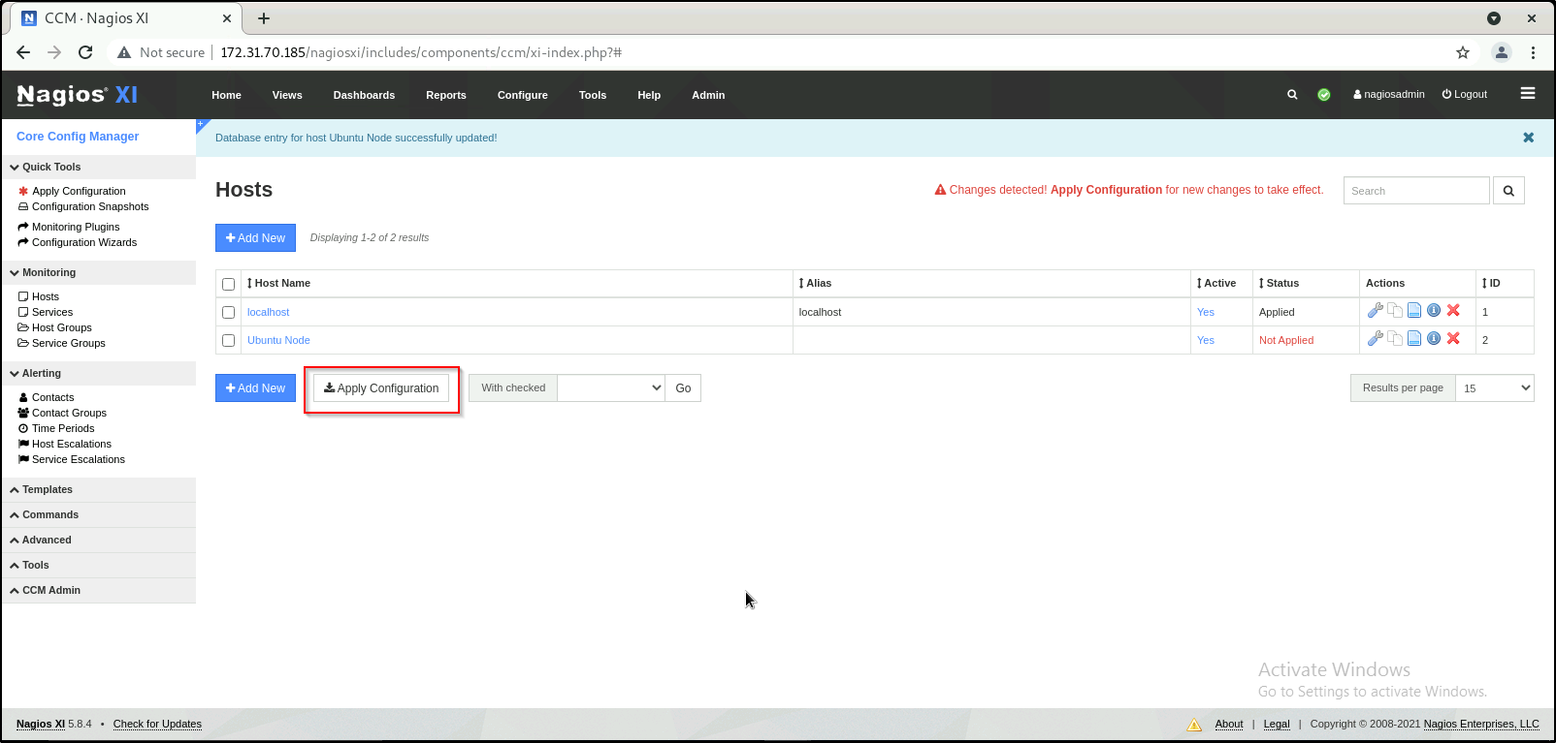

1. You can see the apply configuration successful message as shown below:

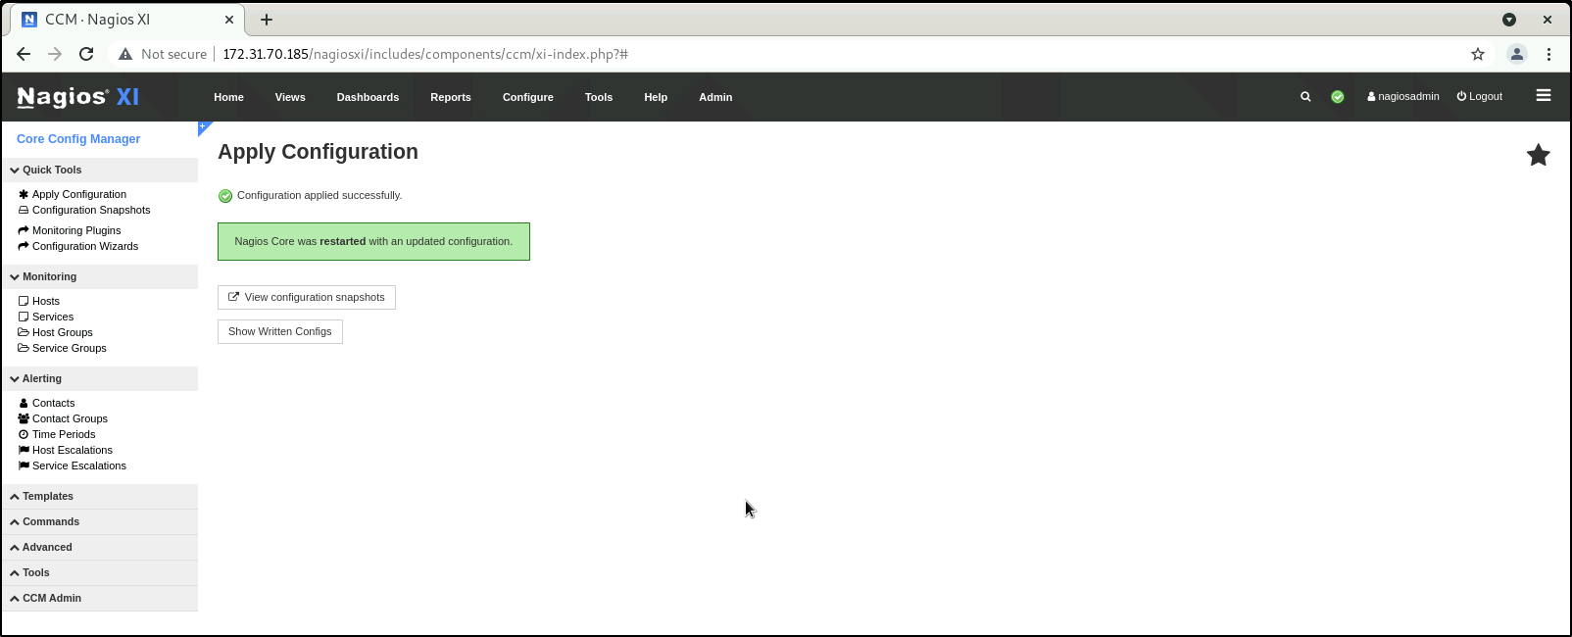

1. You can verify that the host is added to the monitoring tool.

